**URS-07: Admin can add new activity gallery in the Gallery page.**

***Introduction***

        The system should allow admin to add new activity gallery into the database for updating temple activity.

***Precondition and Input***

Admin must login success to the system and link to the Gallery page. Admin input the information of gallery, which is name and description, and then submit to create new gallery into the database.

***Processing***

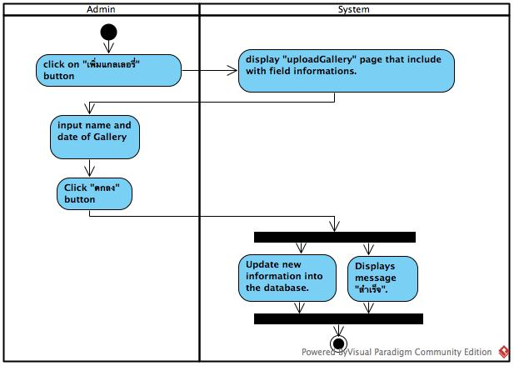

**Figure 7 : Activity Diagram of URS-07**

**Output**

Add new gallery into the database

**System Requirement Specification**

SRS-35 : The system shall provide Gallery page for only admin.

SRS-36 : The system shall provide "เพิ่มอัลบั้ม" button.

SRS-37 : The system shall provide text box to receive the name and the detail of new album.

SRS-25 : The system shall provide “บันทึก” button for updating new information.

SRS-12 : The system shall provide “ยกเลิก” button to cancel.

SRS-26 : The system shall update new information into the database.

SRS-27 : The system shall display confirmed message “สำเร็จ”.

**URS-08: Admin can add new pictures in the gallery.**

***Introduction***

The system should allow admin to add a temple picture into the gallery for updating temple gallery.

***Precondition and Input***

Admin must login success to the system and admin select a gallery on the Gallery page for adding a temple picture into the gallery. Admin can upload pictures, which is not greater than 600*800 and type of the picture should be jpg.

***Processing***

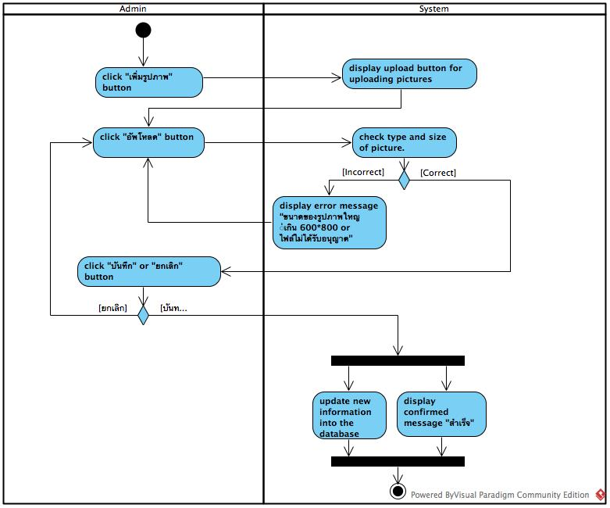

**Figure 8 : Activity Diagram of URS-08**

**Output**

Add a new picture into the database

**System Requirement Specification**

SRS-35 : The system shall provide Gallery page for only admin.

SRS-38 : The system shall provide “เพิ่มรูปภาพ” button for adding new pictures from the admin.

SRS-19 : The system shall provide the UI for receiving new pictures.

SRS-20 : The system shall provide “อัพโหลด” button for uploading the picture.

SRS-21 : The system can check type of file picture.

SRS-22 : The system can check size of picture.

SRS-23 : The system shall display error message “ขนาดของรูปภาพใหญ่เกิน 600*800”.

SRS-24 : The system shall display error message “ไฟล์ไม่ได้รับอนุญาต”.

SRS-25 : The system shall provide “บันทึก” button for updating new information

SRS-12 : The system shall provide “ยกเลิก” button to cancel.

SRS-26 : The system shall update new information into the database.

SRS-27 : The system shall display confirmed message “สำเร็จ”.

**URS-09: Admin can edit details of each gallery.**

***Introduction***

The system should allow admin to edit details of the gallery that are gallery name and gallery date.

***Precondition and Input***

Admin must login success to the system and click “แก้ไขหน้านี้” button for edit

details of gallery. Admin input new gallery details that are gallery name and gallery date.

***Processing***

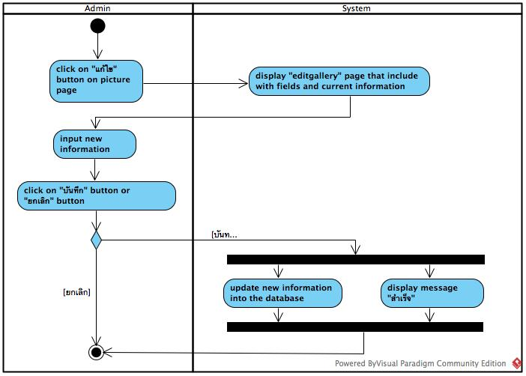

**Figure 9 : Activity Diagram of URS-09**

**Output**

Admin edit details of gallery from the database

**System Requirement Specification**

SRS-39 : The system shall provide Picture page.

SRS-40 : The system shall provide the existing detail of gallery from the database.

SRS-41 : The system shall provide text box for receiving new gallery details.

SRS-25 : The system shall provide “บันทึก” button for updating new information.

SRS-12 : The system shall provide “ยกเลิก” button to cancel.

SRS-26 : The system shall update new information into the database.

SRS-27 : The system shall display confirmed message “สำเร็จ”.

**URS-10: Admin can delete pictures in the gallery.**

***Introduction***

The system should allow admin to delete picture in the gallery by admin click  “ลบ” button for deleting a picture from the database.

***Precondition and Input***

Admin must login success to the system and link to the Gallery page. Admin must click ”ลบ” button for deleting a picture from the database.

***Processing***

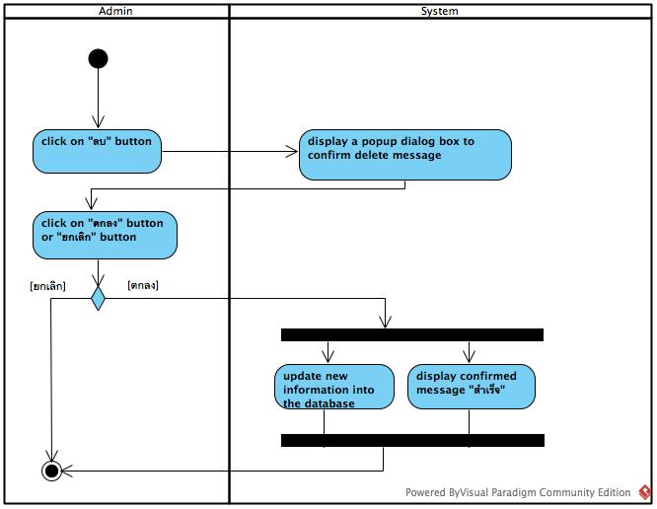

**Figure 10 : Activity Diagram of URS-10**

**Output**

Admin delete picture in the gallery from the database

**System Requirement Specification**

SRS-35 : The system shall provide Gallery page for only admin.

SRS-42 : The system shall provide “ลบ” button for deleting the picture in the gallery.

SRS-43 : The system shall display message “คุณแน่ใจใช่ไหมว่าจะลบรูปภาพนี้!?”.

SRS-44 : The system shall provide “ตกลง” button to confirm.

SRS-45 : The system shall delete selected pictures in the database.

SRS-12 : The system shall provide “ยกเลิก” button to cancel.

SRS-27 : The system shall display confirmed message “สำเร็จ”.

**URS-11: Admin can receive questions from the user.**

***Introduction***

The system should allow admin to receive the user’s question.

***Precondition and Input***

Admin must login success to the system and link to the Question page for receiving the user’s question.

***Processing***

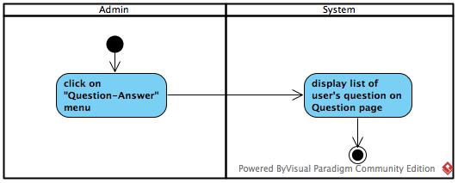

**Figure 11 : Activity Diagram of URS-11**

**Output**

Admin receive the user’s question.

**System Requirement Specification**

SRS-46 : The system shall provide Question page for only admin.

SRS-47 : The system shall receive questions from the database.

SRS-48 : The system shall display list of questions.

**URS-12: Admin can answer the user’s question on the website.**

***Introduction***

The system should allow admin to answer the user’s question by selecting the user’s question from the Question page and admin input the answer on the Answer page.

***Precondition and Input***

Admin must login success to the system and link to the Question page for selecting the question to answer. Admin input the answer in textbox that the system provides and admin click “ส่ง” button for sending answer to the user.

***Processing***

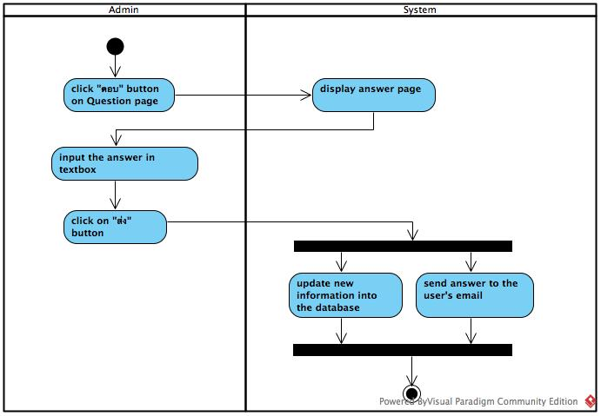

**Figure 12 : Activity Diagram of URS-12**

**Output**

Admin send the answer to the user.

**System Requirement Specification**

SRS-49 : The system shall provide Question page for only admin.

SRS-47 : The system shall receive questions from the database.

SRS-50 : The system shall display list of questions.

SRS-51 : The system shall provide "ตอบ" button for answering the user’s question.

SRS-52 : The system shall provide Answer page for answering the selected question.

SRS-53 : The system shall provide text box for only admin to answer the user’s question.

SRS-44 : The system shall provide “ตกลง” button to confirm.

SRS-12 : The system shall provide “ยกเลิก” button to cancel.

SRS-27 : The system shall display confirmed message “สำเร็จ”.

SRS-54: The system shall add the answer to the database.

SRS-55 : The system shall send the answer to the user's email.

**URS-13: Admin can send news to registered users’ email.**

***Introduction***

The system should allow admin to send news to the registered user by their email.

***Precondition and Input***

Admin must login success to the system and link to the News page for selecting checkbox to send news to the registered user. Admin clicks ”ตกลง” button to confirm sending news.

***Processing***

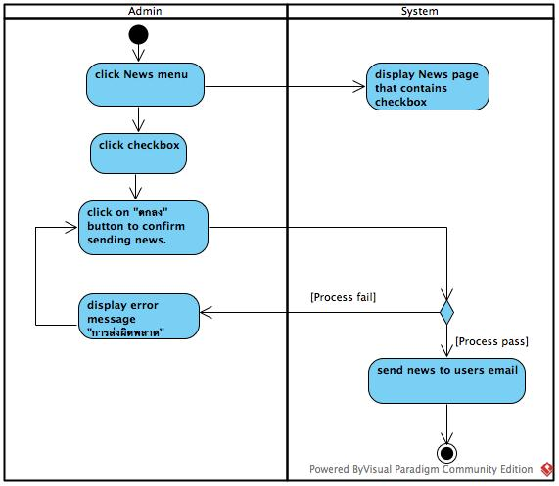

**Figure: Activity Diagram of URS-13**

**Output**

Admin send news to the registered user.

**System Requirement Specification**

SRS-31 : The system shall provide News page for only admin.

SRS-56 : The system shall provide the checkbox“ส่งข่าวสารให้สมาชิก”for selecting to send news to the member.

SRS-57 : The system shall provide UI for showing list of member’s email.

SRS-58 : The system shall provide confirm message “คุณแน่ใจใช่ไหมว่าจะส่งข่าวสารให้สมาชิกทุกคน?” to confirm sending news to member email.

SRS-59 : The system shall receive members’ email from database.

SRS-25 : The system shall provide “บันทึก” button for updating new information.

SRS-60 : The system shall send the news to all members’ email.

SRS-61 : The system shall provide error message “การส่งผิดพลาด” if send email process fail.

SRS-27 : The system shall display confirmed message “สำเร็จ”.

**URS-14: Admin can delete the user’s question.**

***Introduction***

The system should allow admin to delete the user’s question which is impolite question.

***Precondition and Input***

Admin must login success to the system and link to the Question page for selecting the impolite question to delete.

***Processing***

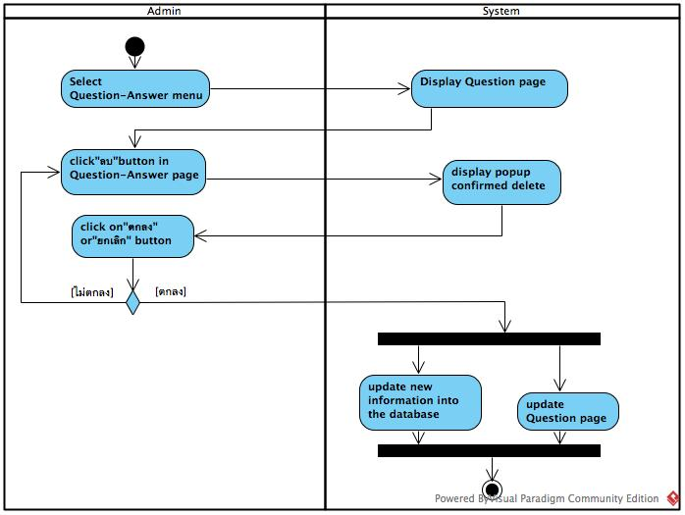  
**Figure 14 : Activity Diagram of URS-14**

**Output**

Admin delete impolite question from the database.

**System Requirement Specification**

SRS-49 : The system shall provide Question page for only admin.

SRS-50 : The system shall receive questions from the database.

SRS-51 : The system shall display list of questions.

SRS-62 : The system shall provide “ลบ” button for deleting the question, which is  impolite question.

SRS-63 : The system shall display message "คุณแน่ใจใช่ไหมว่าจะลบคำถามนี้!?".

SRS-44 : The system shall provide “ตกลง” button to confirm.

SRS-12 : The system shall provide “ยกเลิก” button to cancel.

SRS-64 : The system shall delete the question in the database.

SRS-27 : The system shall display confirmed message “สำเร็จ”.

**URS-15: User can register to the website.**

***Introduction***

The system should allow user to create a new user account in the Register page by user input a data and save it into the database.

***Precondition and Input***

User must access on the Register page and input a first name, lass name, password and re-password for create user account information.

***Processing***

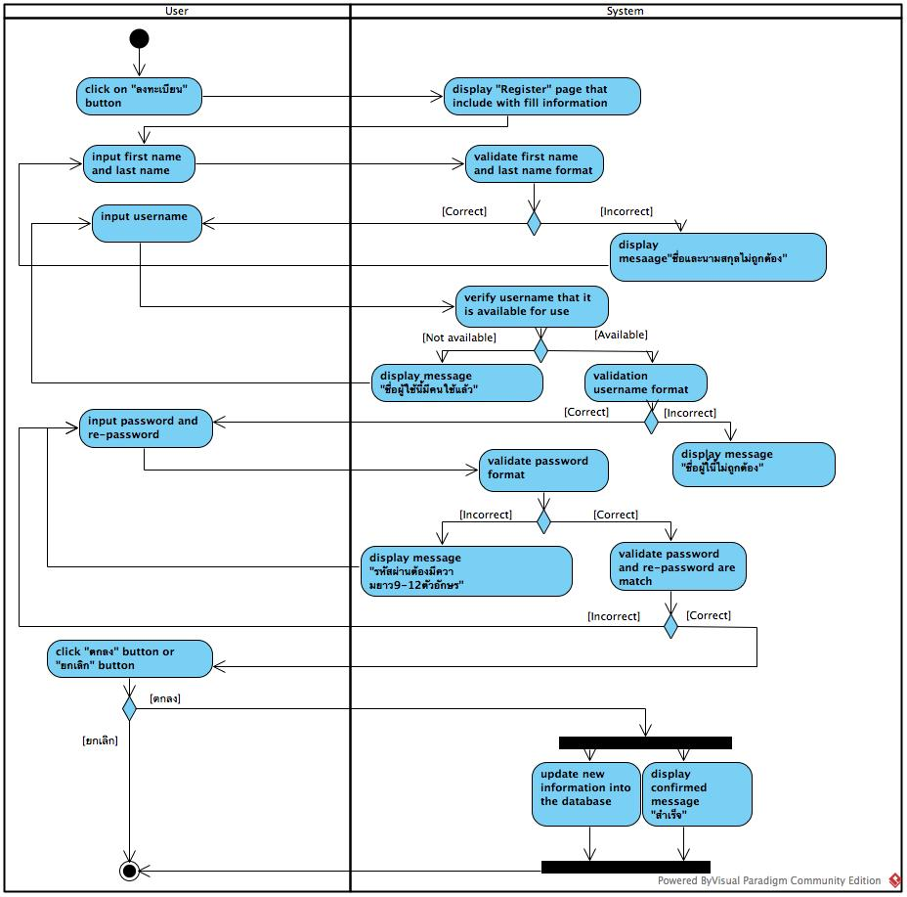

**Figure 15 : Activity Diagram of URS-15**

**Output**

Add new user account information into the database.

**System Requirement Specification**

SRS-01 : The system shall provide Login page.

SRS-02 : The system shall provide text box for receiving username and password.

SRS-03 : The system shall provide “เข้าสู่ระบบ” button for accessing to the system.

SRS-04 : The system shall receive username and password.

SRS-05 : The system shall check username and password format.

SRS-06 : The system shall verify the login account.

SRS-07 : The system shall display error message "ชื่อผู้ใช้ หรือ รหัสผ่าน ไม่ถูกต้อง".

SRS-08 : The system shall redirect to Home page.